Polynomial and Rational Functions Name _________________________
A2RCC U8D7 Homework

- Divide the polynomials.
- Simplify $\frac{2x^{2}+15x+18}{x+6}$ by performing polynomial long division.

- Rewrite the result as an equivalent multiplication equation.

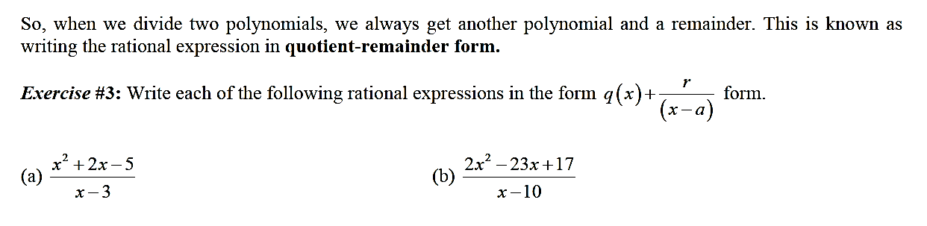

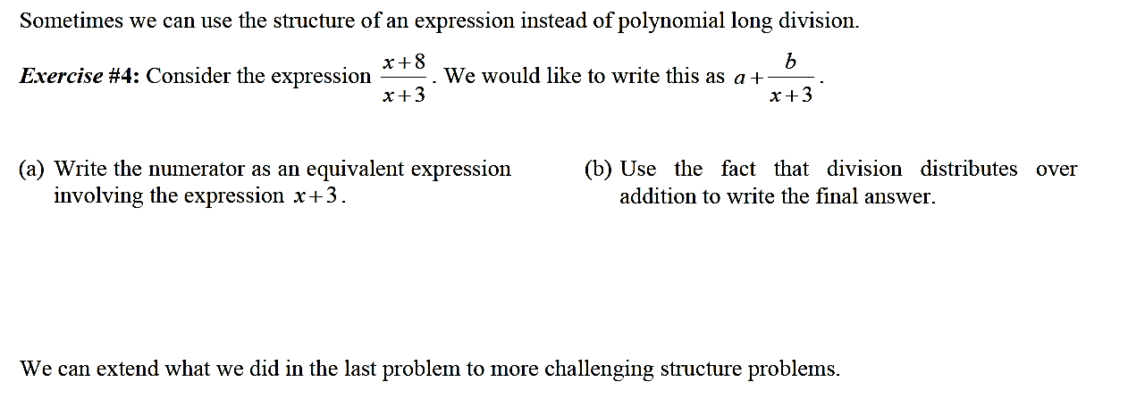
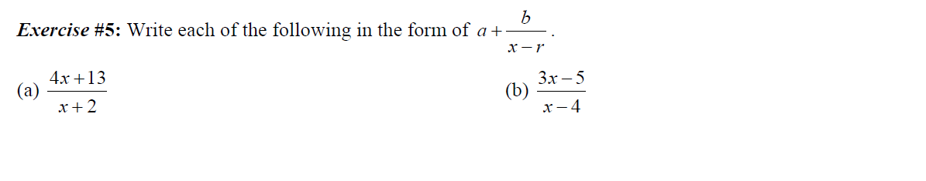

6) Divide and express in quotient-remainder form.

$a) (x^{3}+7x^{2}+14x+3)÷(x+2)$ b) $(x^{3}-10x^{2}-20x+26)÷(x-5)$

